#add two hard disk

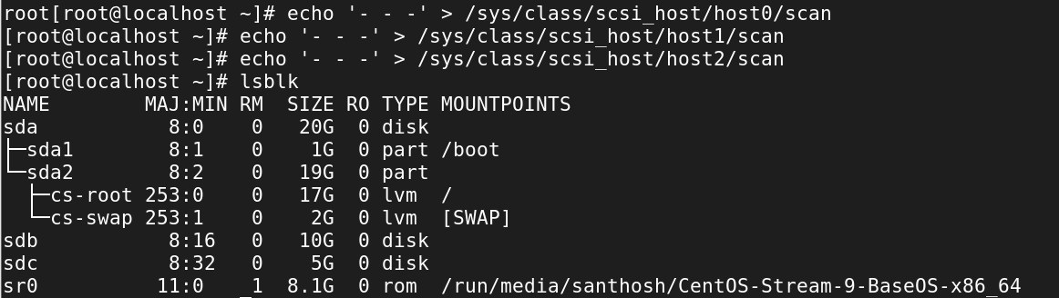

Partition

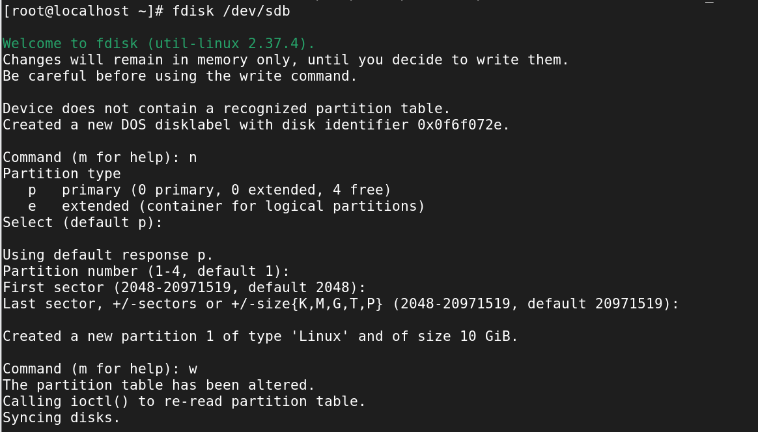

create physical volume

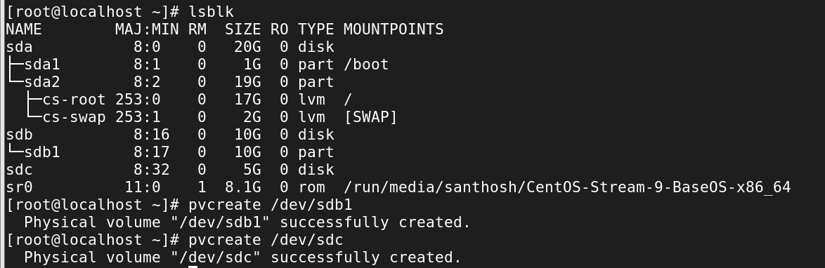

physical volume status

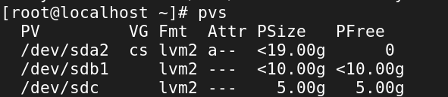

create volume group



Vg extend



volume group status

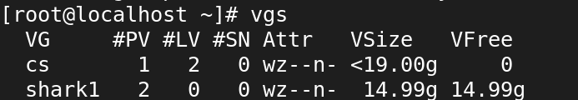

create logical volume

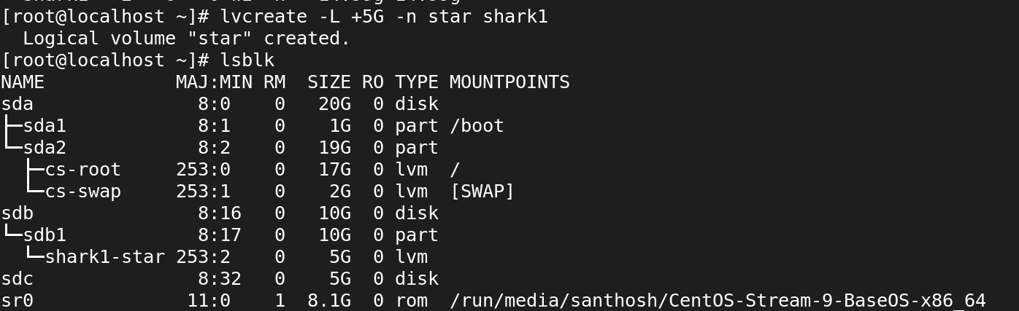

create filesystem

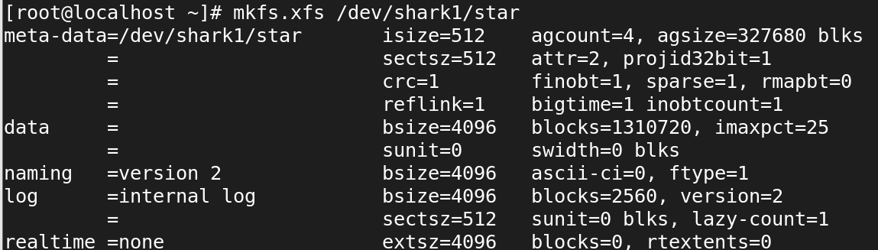

mount the filesystem

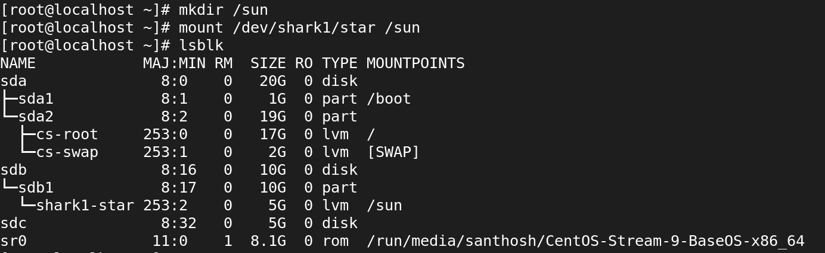

df -hT

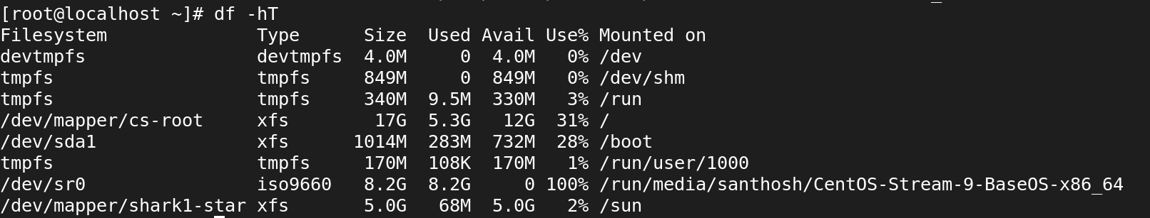

cd

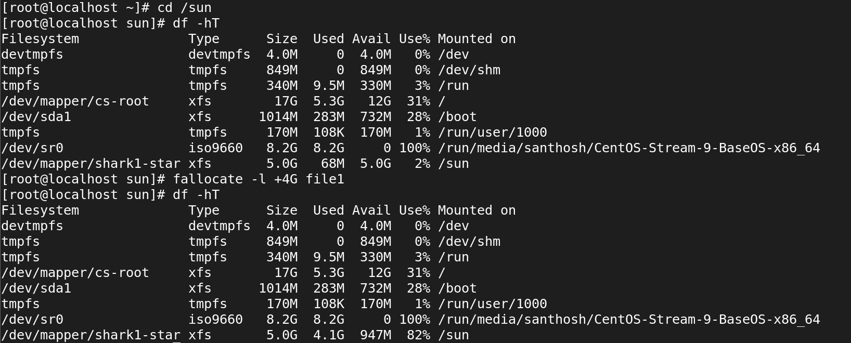



Lvextend

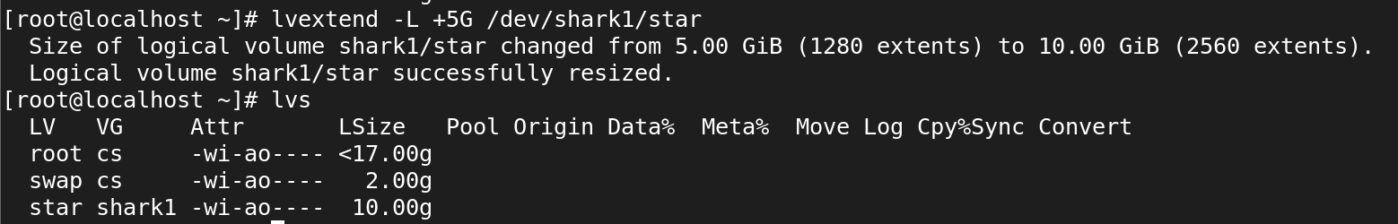

Crete file system

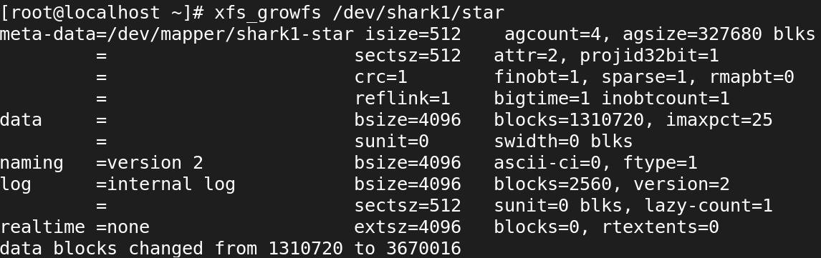

df -hT

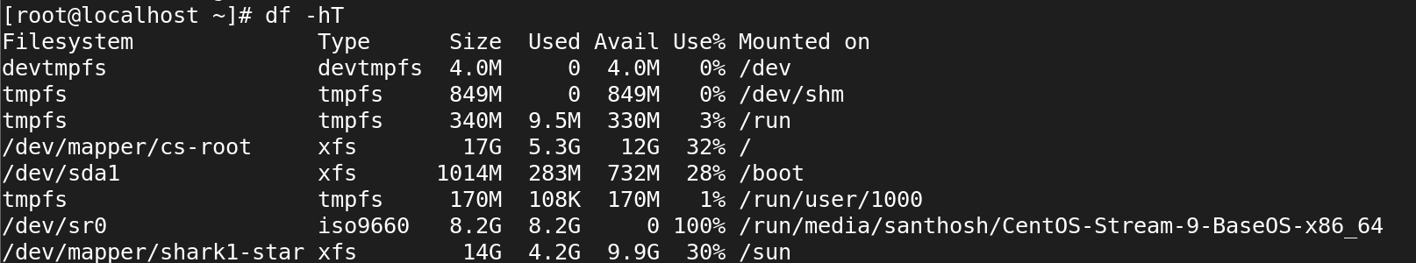

Fallocate

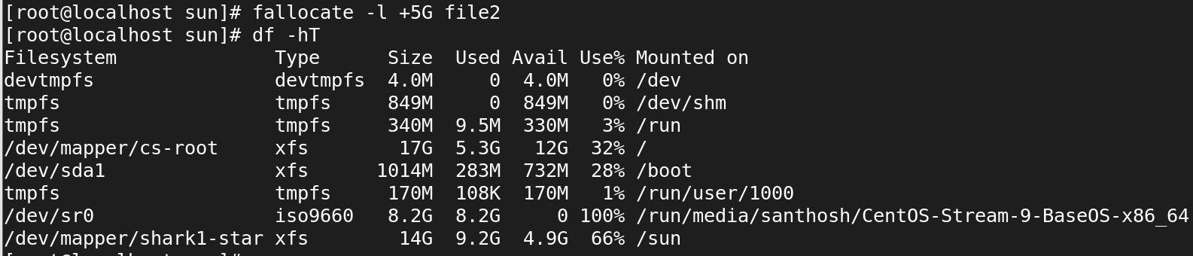

Permanently mount



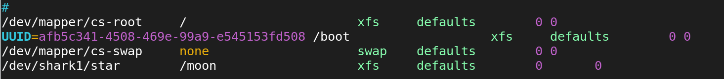

Restart

